**Diwali Sales Data Analysis**

**Introduction**

This project aims to analyze Diwali sales data to gain insights into customer behavior and preferences. The dataset used for analysis is provided in a CSV file called "[Diwali Sales Data.csv](https://www.kaggle.com/datasets/bishtudas/diwali-sales-dataset)". The analysis focuses on various aspects such as gender, age group, state, marital status, occupation, product category, and product ID. The project utilizes Python libraries such as NumPy, pandas, matplotlib, and seaborn for data manipulation, visualization, and analysis.

**Data Import and Preprocessing**

The first step involves importing the necessary Python libraries and reading the CSV file using the pandas library's `read_csv()` function. The encoding parameter is set to "unicode_escape" to avoid any potential encoding errors. The data frame's shape is examined using the `shape` attribute, and the first few rows of the data frame are displayed using the `head()` function. Similarly, the last few rows can be viewed using the `tail()` function. The `info()` function provides information about the data types and missing values in the data frame.

*# Checking the data to analyze the need for cleaning areas*

df.info()

RangeIndex: 11251 entries, 0 to 11250

Data columns (total 15 columns):

# Column Non-Null Count Dtype

--- ------ -------------- -----

0 User_ID 11251 non-null int64

1 Cust_name 11251 non-null object

2 Product_ID 11251 non-null object

3 Gender 11251 non-null object

4 Age Group 11251 non-null object

5 Age 11251 non-null int64

6 Marital_Status 11251 non-null int64

7 State 11251 non-null object

8 Zone 11251 non-null object

9 Occupation 11251 non-null object

10 Product_Category 11251 non-null object

11 Orders 11251 non-null int64

12 Amount 11239 non-null float64

13 Status 0 non-null float64

14 unnamed1 0 non-null float64

dtypes: float64(3), int64(4), object(8)

Unrelated or blank columns are dropped using the `drop()` function, specifying the column names and axis. Null values are checked using the `isnull()` function, and rows with missing values are dropped using the `dropna()` function. The data type of the "Amount" column is converted to integer using the `astype()` function.

**Exploratory Data Analysis**

The exploratory data analysis phase involves visualizing and analyzing different aspects of the data to uncover patterns, trends, and insights.

**Gender Analysis**

The analysis begins with examining the gender distribution of the buyers. A bar chart is plotted using the `countplot()` function from the seaborn library to visualize the count of buyers for each gender. Additionally, a bar chart is created to compare the total amount spent by each gender.

*# plotting a bar chart for Gender and it's count*

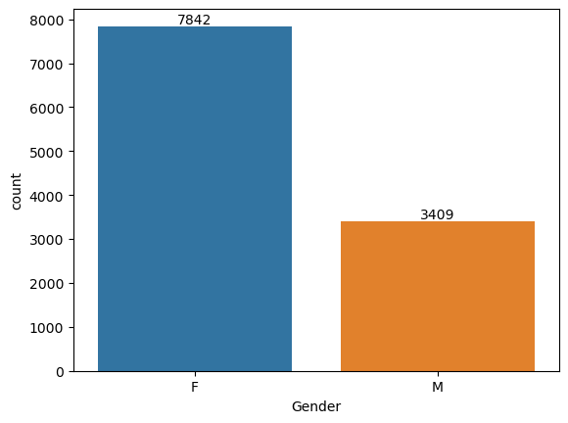

*# plotting a bar chart for gender vs total amount*

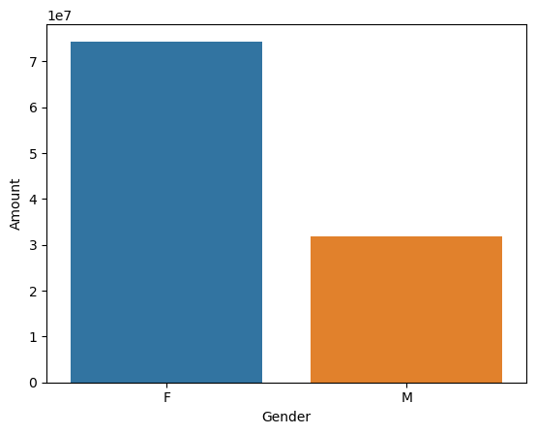

From above graphs we can see that most of the buyers are females and even the purchasing power of females are greater than men.

**Age Group Analysis**

The next analysis focuses on the age groups of the buyers. A bar chart is created to visualize the count of buyers for each age group, categorized by gender. Another bar chart is generated to compare the total sales amount for each age group.

*#which gender in age group is more active in shopping*

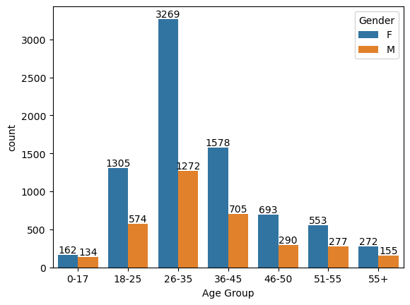

*#Total Amount vs Age Group*

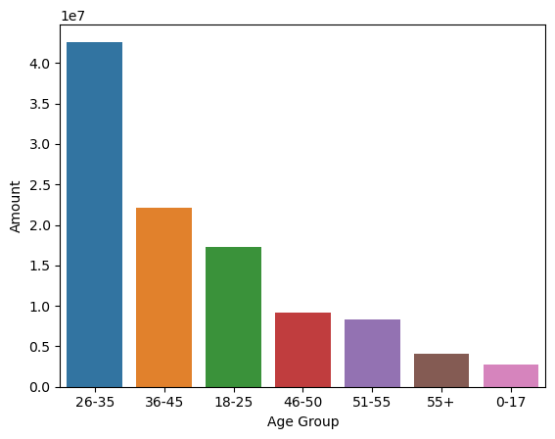

From above graphs we can see that most of the buyers are of age group between 26-35 yrs female

**State Analysis**

The analysis shifts towards the states from which the orders originate. Two bar charts are created to show the total number of orders and the total sales amount from the top 10 states.

*#Total number of orders from top 10 states*

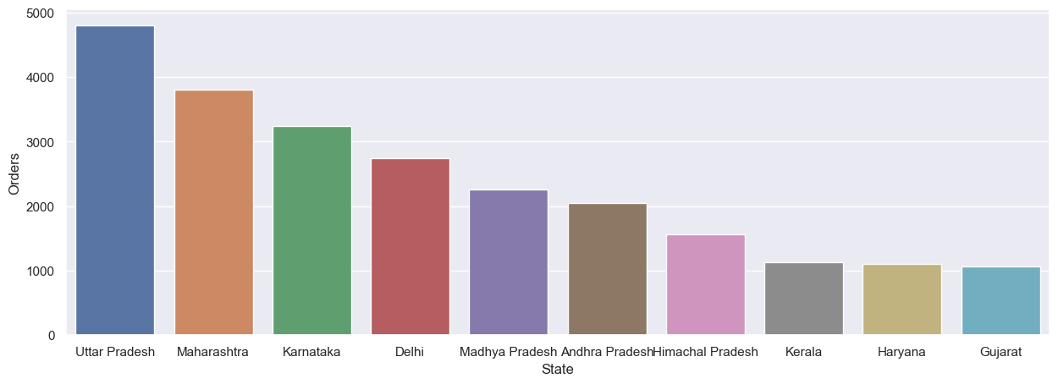

*#Total amount/sales from top 10 states*

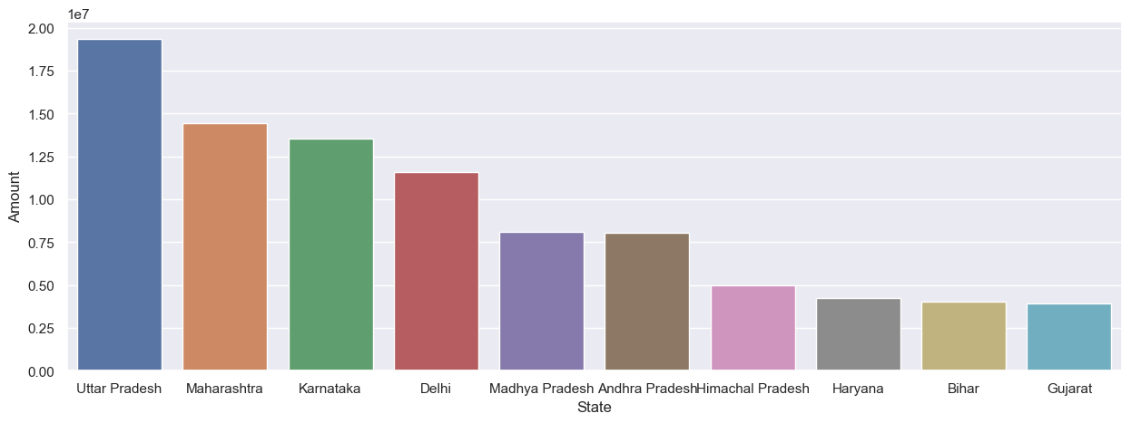

From above graphs we can see that most of the orders & total sales/amount are from Uttar Pradesh, Maharashtra and Karnataka respectively

**Marital Status Analysis**

The marital status of the buyers is analyzed next. A bar chart is plotted to display the count of buyers for each marital status. Another bar chart is generated to compare the total sales amount for each marital status, categorized by gender.

*#count of marital status (zero - Married, one - Unmarried)*

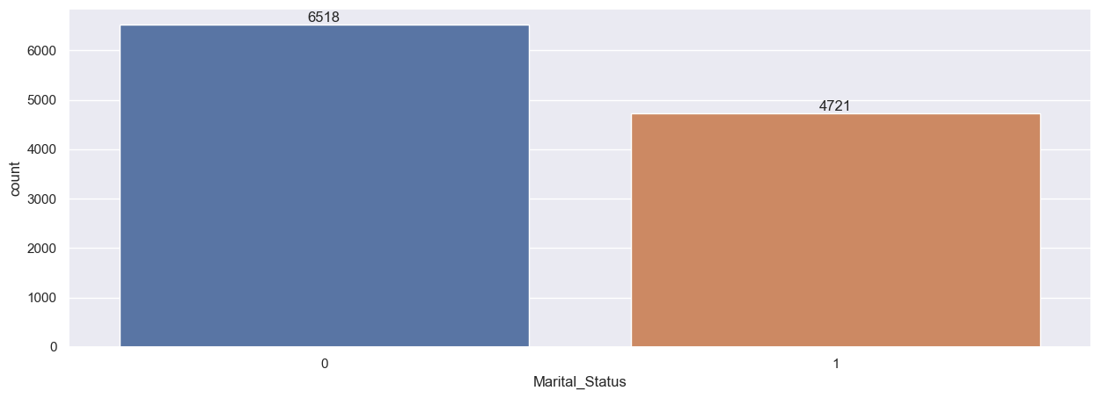

*#count of marital status amoung gender*

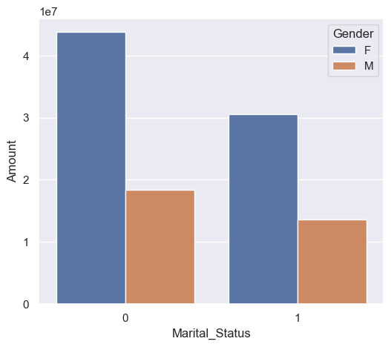

From above graphs we can see that most of the buyers are married (women) and they have high purchasing power

**Occupation Analysis**

The analysis then focuses on the occupation of the buyers. A bar chart is created to visualize the count of buyers for each occupation. Additionally, a bar chart is generated to compare the total sales amount for each occupation.

*# count of Occupation*

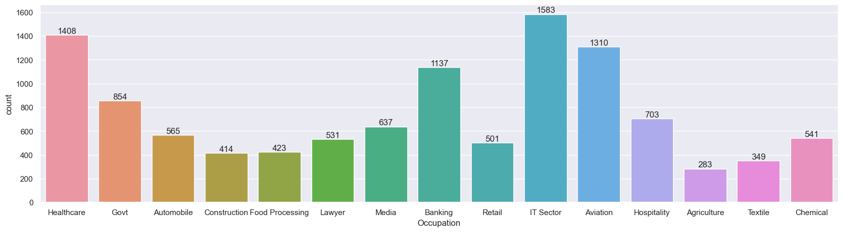

*#Total amount/sales from Occupation*

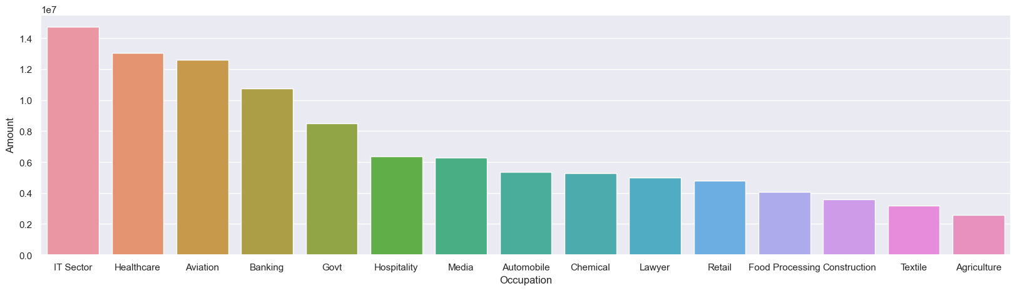

From above graphs we can see that most of the buyers are working in IT, Healthcare and Aviation sector

**Product Category Analysis**

The analysis proceeds to examine the product categories. A bar chart is plotted to display the count of products sold in each category. Another bar chart is created to compare the total sales amount for the top 10 product categories.

*# Count of each Product Category*

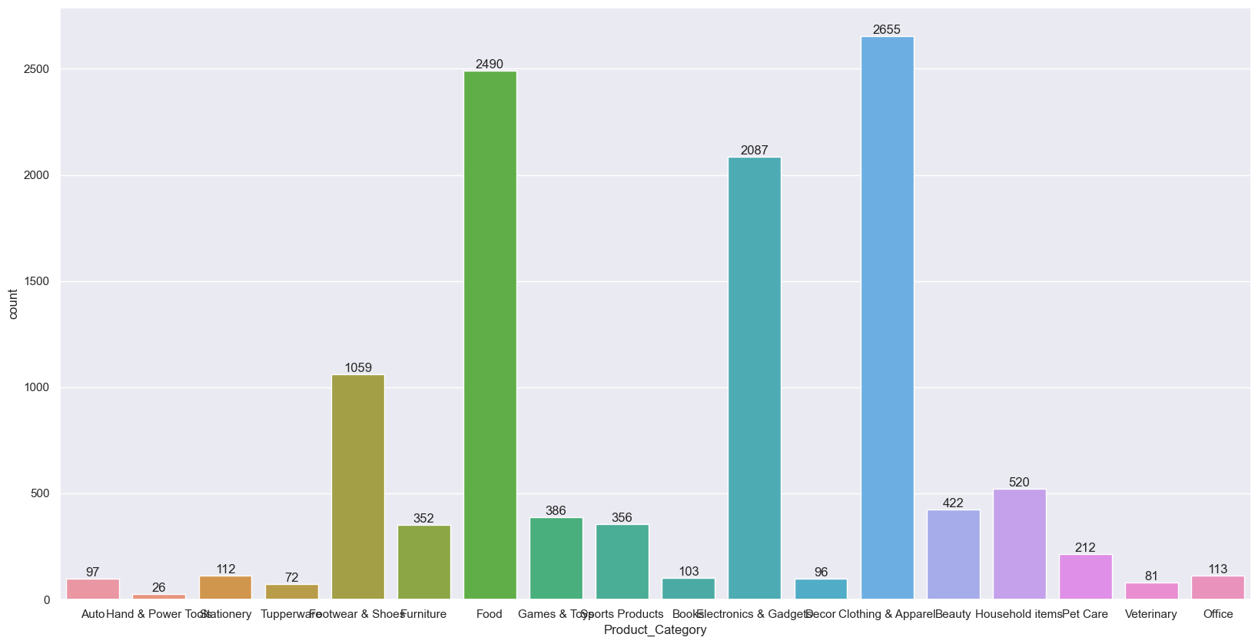

*# Total amount/sales from Product Category*

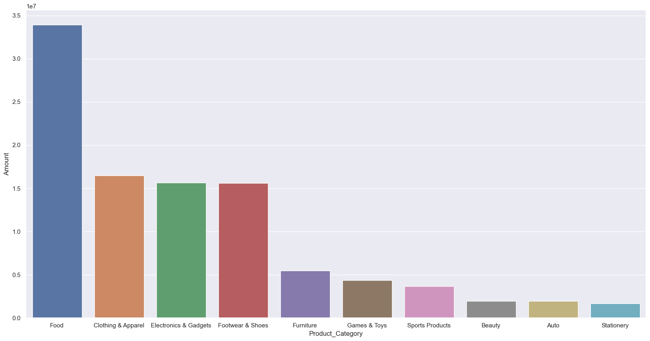

From above graphs we can see that most of the sold products are from Food, Clothing and Electronics category

**Product ID Analysis**

The last analysis explores the product IDs. A bar chart is created to show the total number of orders for the top 10 product IDs. Furthermore, a bar chart is generated to visualize the top 10 most sold products.

*#Total number of orders from top 10 product ID*

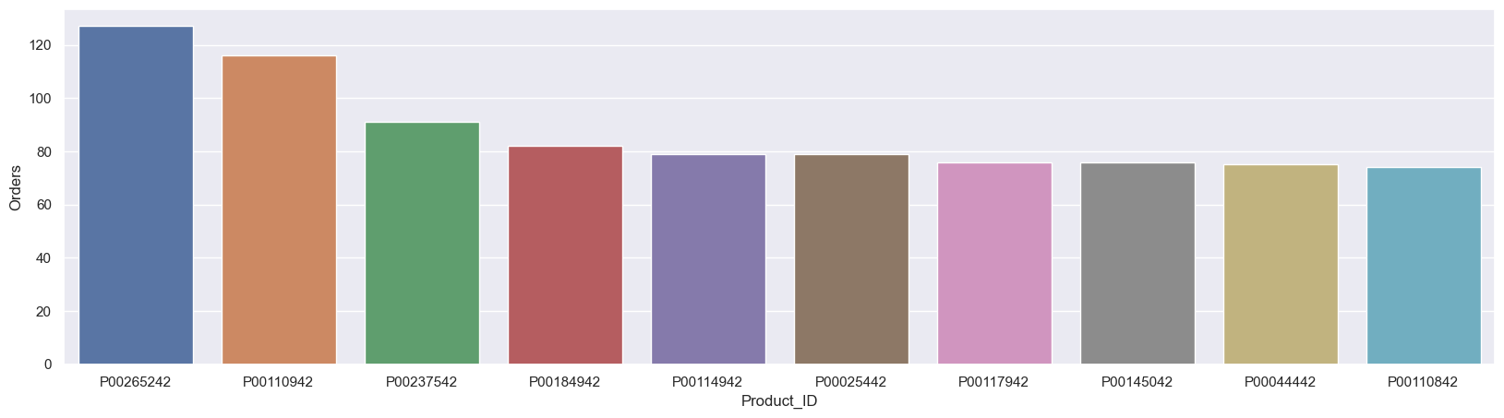

*#top 10 most sold products*

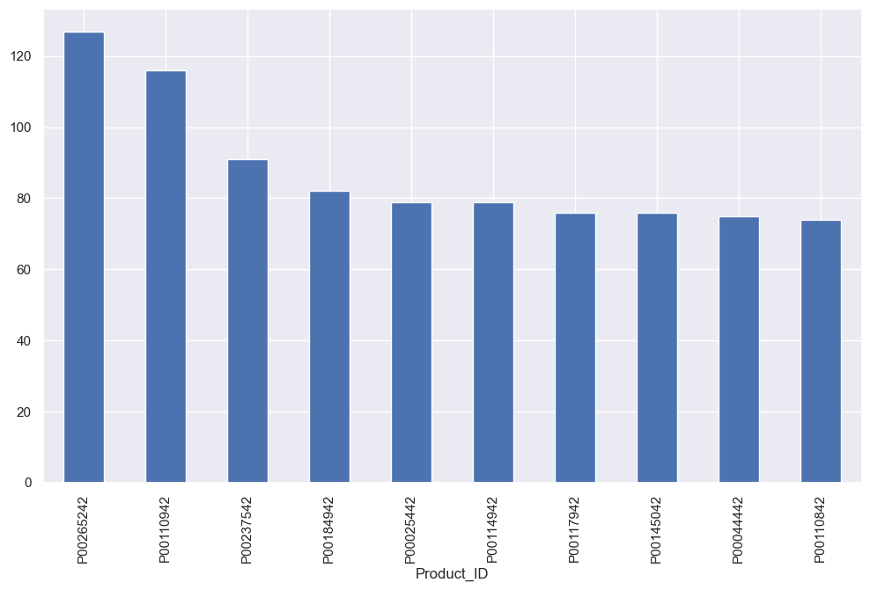

**Conclusion**

* The majority of the buyers are females, and their purchasing power exceeds that of males.
* The most active age group in terms of shopping is females aged between 26-35 years.
* The states with the highest number of orders and total sales amount are Uttar Pradesh, Maharashtra, and Karnataka.
* Married women have a higher purchasing power compared to unmarried women.
* The most common occupations among buyers are in the IT, healthcare, and aviation sectors.
* The most popular product categories are food, clothing, and electronics.

**Reference**

**Dataset :-** https://www.kaggle.com/datasets/bishtudas/diwali-sales-dataset